Task 1 – Connect Excel File Using Import Mode
Answer:
I created an Excel file containing my favorite restaurants with three columns: Restaurant Name, Cuisine, and Rating.
I connected the Excel file to Power BI Desktop using the Get Data option and selected Excel Workbook.
I selected the required sheet in the Navigator window and clicked Load to import the data into Power BI.
The restaurant data was successfully loaded into Power BI using Import mode.

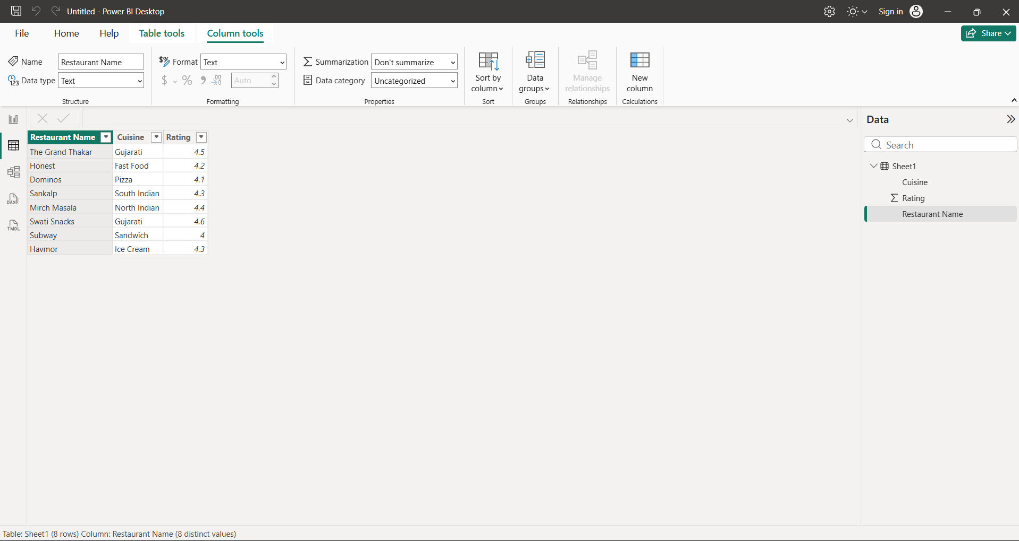

Task 2 – Connect IPL Match Results CSV File
Answer:
I created an IPL Match Results CSV file containing match dates, team names, and scores.
I connected the CSV file to Power BI Desktop using Get Data → Text/CSV and loaded the data successfully.
Import vs DirectQuery:
Import mode stores a copy of the data in Power BI, whereas DirectQuery retrieves data directly from a supported data source when needed.
Note: Power BI does not support DirectQuery for CSV files. Therefore, this CSV file was loaded using Import mode.

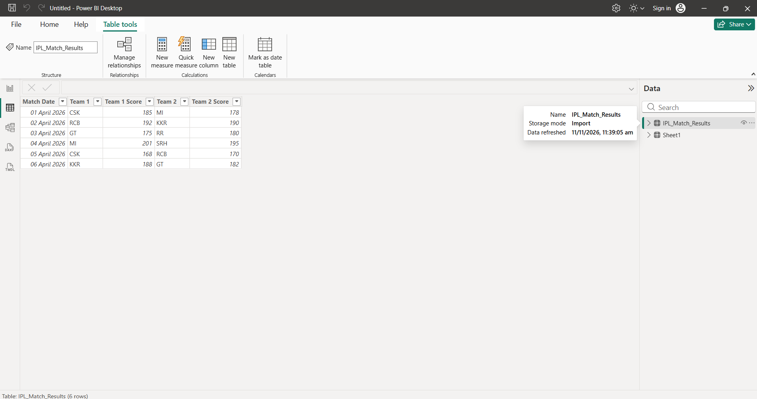

Task 3 – Import Movie Data Using Web Connector
Answer:
I used the Web connector in Power BI Desktop to connect to a public movie data webpage.
I selected the required table containing movie titles and ratings and loaded the data into Power BI.
After loading the data, I created a Table Visual in Report View and added the Movie Title and Rating fields.
The movie titles and their ratings were successfully displayed in the table visual.

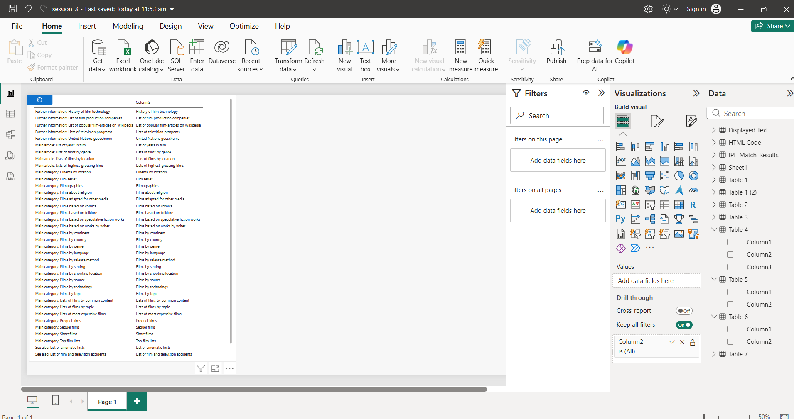

Task 5 – Combine Data from Two Different Sources
I combined restaurant data from an Excel file and customer reviews from a CSV file.
I created BlinkMart Data set table with unique IDs and established a One-to-Many relationship with the User Reviews table.



